Eyeconic-Storage Boxes Shop Management System

Use-Case Specification: Remove Storage Boxes

Version <1.0>

Revision History

|  |  |  |  |
| --- | --- | --- | --- |
| **Date** | **Version** | **Description** | **Author** |
| <05/11/2019> | <1.0> | creating use case | Nguyễn Tuấn Anh |
|  |  |  |  |

Table of Contents

1. Remove Storage Boxes 4

1.1 Brief Description 4

2. Flow of Events 4

2.1 Basic Flow 4

2.2 Exception 4

2.2.1 Remove Storage Boxes 4

2.2.2 Confirming editing the brand 5

3. Special Requirements 5

4. Preconditions 5

4.1 Admin must be logged in 5

5. Postconditions 5

6. Extension Points 5

Remove Storage Boxes

# Remove Storage Boxes

## Brief Description

This use case defines the step of delete exist Storage Boxes from the database.

Storage Boxes are removed by the admin.

# 2. Flow of Events

## 2.1 Basic Flow

The system administration selects the Storage Boxes data to remove. The administrator deletes the Storage Boxes data from the website. The system displays the updated management parameter value and logs the change

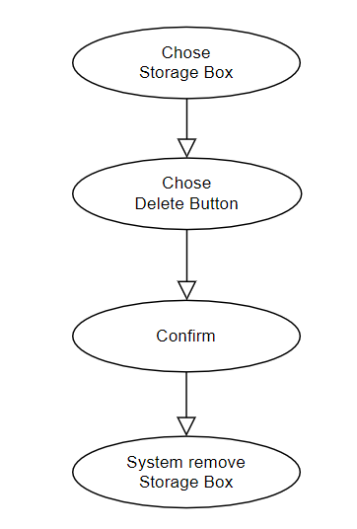

***Basic flow of Removing Storage Boxes***

Step 1: Choose the Storage Boxes you want to remove

Step 2: Click remove button

A modal view shows up with content “Are you sure want to remove this item?”

and two button “Yes” and “No”

Step 3: Confirming adding the Storage Boxes by clicking the “Yes” button.

Step 4: Storage Boxes are removed from database and no longer appeared on the screen.

## 2.2 Exception

### 2.2.1 Remove Storage Boxes

The remove button cannot be clicked or isn’t appeared on the screen

### 2.2.2 Confirming editing the brand

The “Yes” button is clicked but the brand are not removed

# 3. Special Requirements

No Special Requirements

# 4. Preconditions

## 4.1 Admin must be logged in

User must already login as the administrator of the website

# 5. Postconditions

All others product can be shown and purchases as normal.

Deleted Storage Boxes cannot be seen on the screen or database.

# 6. Extension Points

Administrator check the website and the system to ensure that the Storage Boxes is completely removed.